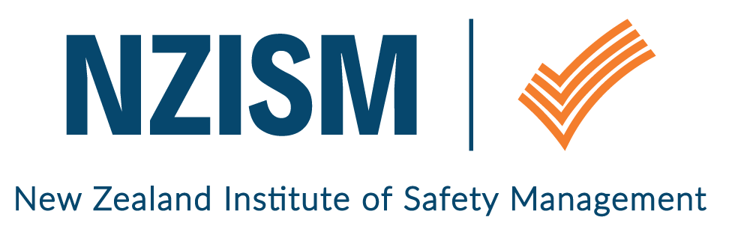
Wellington Branch

October 2018 Newsletter

Review of last event held  Wednesday 3 October, Wellington | 24 members enjoyed a presentation from Mike Sarten of Fletchers, regarding working under an Enforceable Undertaking (EU). The willingness of Fletchers to share a general overview of the incident that led to the Undertaking and how they have implemented the requirements, was appreciated. The full EU is available publically on the WorkSafe website.  Mike discussed the importance of H&S professionals understanding the definition of ‘Temporary Works’ and the potential associated risks which must be assessed by competent engineers.  The incident highlighted there is no AS/NZ Standard for temporary works and WorkSafe used British Standard BS5975:2008 (a Code of Practice for temporary works procedure) as a benchmark. Fletcher’s new temporary works procedure incorporates processes from that standard and will be a higher standard that current industry practice in New Zealand. There are higher level discussions to develop an AS/NZ Standard which is a positive step for all.  NZISM member, Mauric Rolleff, also from Fletchers, updated us on progress with recent safety forums with interested parties to develop a set of standards for the Temporary Labour Hire industry. Given the level of conversation this generated, we have invited Mauric back in early 2019 to present on this once WorkSafe have released the documentation.
November event  The National Library  70 Molesworth Street  Wellington | Tuesday 6 November  12:00pm – 12:15pm: Networking  12:15pm – 1:15pm: Presentation followed by Q&A  Bridgette Jennings, Managing Director of Chemsafety, is our November guest presenter. Bridgette answered the call of members she met at HASNZ who expressed an interest in hearing from her company, and she will be discussing hazardous substances management. We look forward to any tips to help navigate the Health and Safety at Work (Hazardous Substances) Regulations to ensure risks are understood and managed correctly.  Please rsvp via Eventbrite for this event.
Bring a guest
Members are encouraged to bring along guests to the monthly seminars. Whilst there is a preference to translate the visits to membership, our focus is on growing risk management awareness amongst a cross section of people. Safety is everyone’s responsibility – not just the H&S professional.

Local H&S scene / What’s going on | 9 October  Manawatu NZISM Branch CPD Day  Human Factor Considerations in Risk Assessment & Management  The Manawatu Branch is keen to have as many people as possible at this event. If you live in the Porirua/Otaki area, you are encouraged to consider attending this event or feel free to share it with others who could benefit from the information. For full information please see the Manawatu Branch section of the NZISM calendar.  Health focus events  Mental Health Awareness week  Stroke Week  Breast Cancer Awareness month  If you’d like to promote an event or share information that would be helpful to NZISM members, please email well.nzism@gmail.com.
Other Information | Contact information  A reminder to ensure your profile on the NZISM website – https://www.nzism.org is up to date. The success of the Wellington branch relies on the input of its members and our ability to send communications to you. Please let other members know if they mention they are not receiving emails from us.  Thank you and welcome  Mike Sarten and Denise Steele have kindly answered the call for volunteers on the Wellington leadership group. It’s great to have representation from the Porirua and Hutt Valley regions.  HASANZ Scholarships  For those who missed the announcement, you can find all the information about the new HASANZ Scholarship Program on their website. Please share this with others in your workplaces who are interested in the health and safety career pathway.
Important stuff to know | Wellington monthly events are scheduled for the first Tuesday of every month at The National Library, Thorndon. Keep an eye on the NZISM Calendar on the website for more information.  A reminder also, to check out our neighbouring Regions events on the NZISM Calendar. There may be something on in another Branch that is relevant to you.

